**Part 6 - Template Driven Forms**

Here we’re going to learn about

1. What is template driven forms
2. How to use template driven forms
3. Validation and Dynamic Error Message
4. Submit forms
5. WHAT IS TEMPLATE DRIVEN FORMS

This is one of ways to create forms in angular. Template driven forms using “Two way binding” concept. Two way binding means when we change the value at template forms then the value at the component will be updated automatically, and when we change the value at the component then the value at template form also will be updated.

1. HOW TO USE IT

In order to enable template driven forms we have to import formsModule

Open app.module.ts



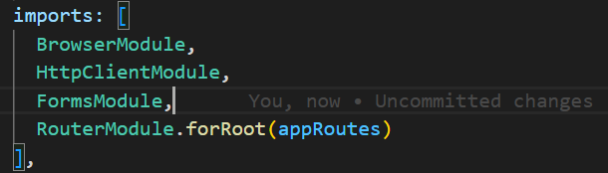

by adding FormsModule we will be associated to ngForm directive.



Basically “ngForm” is hidden instance. However we able to expose this instance by adding #Form (notes : #From can be changed with different name like #f, #frm and etc). Now we can use #Form variable that will be pointed to ngForm directive.

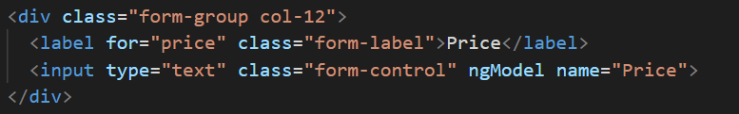

Once we have used ngForm directive, we can’t to get each value from template forms. We need to use ngModel.



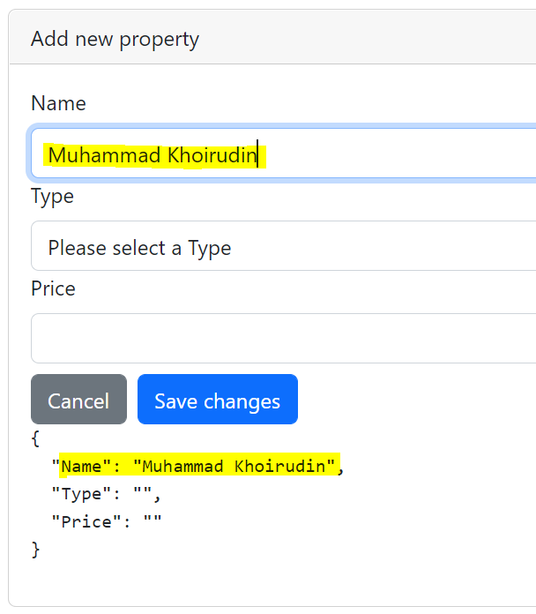

1. VALIDATION AND ERROR MESSAGE

<https://angular.io/api/forms/Validators>

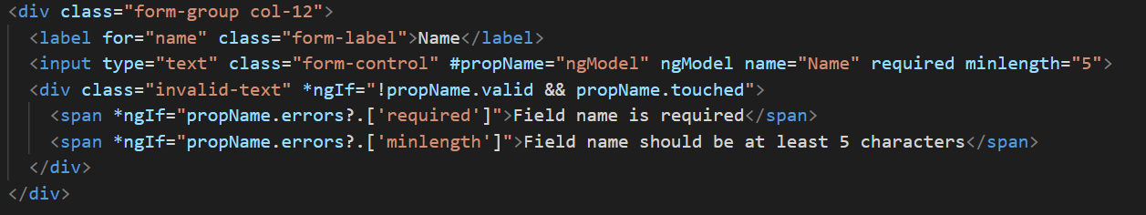

1. We only need to use attribute HTML like required, minlength etc
2. We have to wrap ngModel instance into variable (#propName, can be whatever any name)
3. Logic : Only if the form is not valid (it means no value match with validation) & the field has touched (cursor in the form)



“?” is called elvis operator, it means only call the property (required, minLength etc) if the property on the left “errors” is not null.

1. SUBMITTING FORMS



You have to use submit type button



don’t forget to use submit directive inside the form control html



Disabling the button if the form is still invalid (doesn’t match with validation)

Open the component. Here we use view child decorator



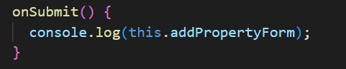

Or



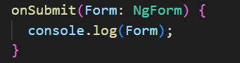

[https://www.youtube.com/watch?v=6aOg_IMQjyE&list=PL_NVFNExoAxclqXo9fLAeP0G2Qp56Fu8C&index=15](https://www.youtube.com/watch?v=6aOg_IMQjyE&list=PL_NVFNExoAxclqXo9fLAeP0G2Qp56Fu8C&index=16)